Normal Patients
 | Male |  | Female
Age Group (Years) | n | % Black | n | % Black
0 - 19 | 19 | 47.4 | 18 | 72.2
20 - 29 | 15 | 86.7 | 14 | 100
30 - 39 | 14 | 71.4 | 14 | 100
40 - 49 | 15 | 80.0 | 14 | 85.7
50 - 59 | 15 | 66.7 | 14 | 85.7
60 - 69 | 13 | 61.5 | 14 | 64.3
70 - 79 | 14 | 71.4 | 14 | 64.3
80 - 89 | 15 | 46.7 | 15 | 60.0
90 - 99 | 10 | 30.0 | 10 | 70.0
Total | 130 | 63.1% | 127 | 78.0%

Table 1. Demographic characteristics of the normal patient cohort, stratified by age group and sex. Black patients comprised 70.4% of the cohort; the remaining patients were White (19.1%), more than one race (7.4%), Asian/Mideast Indian (0.4%), or unknown/not reported (2.7%).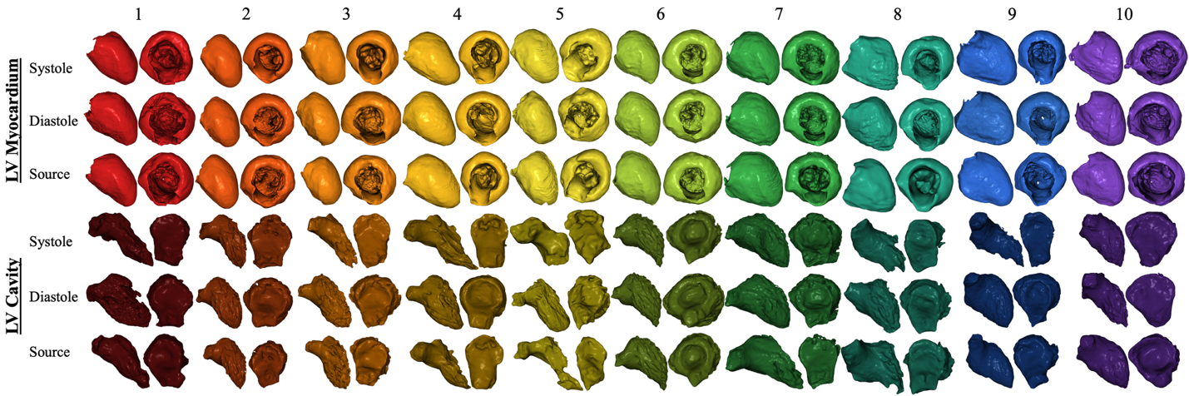
Figure 1. Three-dimensional segmentations used to validate conservation of left ventricular myocardial mass (LVMM) throughout the cardiac cycle. Ten patients underwent ECG-gated CT and CTA source scans in immediate succession. The left ventricular myocardium (top) and cavity (bottom) are shown for each patient at end-systole, end-diastole, and on the CTA source scan. Each patient is represented by a unique color, with darker shades denoting the corresponding left ventricular cavity.
Left Ventricular Myocardial Mass (LVMM) (g)
Patient Number | End-Systole | End-Diastole | Source | Average (± SD) | Coefficient of Variation (%)
1 | 133 | 134 | 135 | 134 ± 1 | 0.7
2 | 220 | 226 | 213 | 219 ± 6 | 2.9
3 | 234 | 248 | 226 | 236 ± 11 | 4.7
4 | 148 | 152 | 141 | 147 ± 6 | 3.8
5 | 119 | 125 | 122 | 122 ± 3 | 2.8
6 | 242 | 239 | 232 | 238 ± 5 | 2.2
7 | 304 | 304 | 296 | 301 ± 5 | 1.5
8 | 127 | 126 | 130 | 128 ± 2 | 1.9
9 | 181 | 175 | 155 | 170 ± 13 | 7.7
10 | 124 | 133 | 124 | 127 ± 5 | 4.1
Average | 183 | 186 | 178 | 182 ± 4 | 2.4
Left Ventricular Volume (cc)
Patient Number | End-Systole | End-Diastole | Source | Average (± SD) | Coefficient of Variation (%)
1 | 42 | 101 | 74 | 72 ± 30 | 41.0
2 | 96 | 182 | 137 | 138 ± 43 | 31.1
3 | 61 | 173 | 119 | 118 ± 56 | 47.4
4 | 43 | 125 | 43 | 71 ± 47 | 67.1
5 | 12 | 82 | 20 | 38 ± 38 | 99.5
6 | 124 | 165 | 133 | 141 ± 21 | 15.2
7 | 169 | 202 | 88 | 153 ± 59 | 38.2
8 | 26 | 81 | 43 | 50 ± 28 | 56.3
9 | 56 | 176 | 135 | 122 ± 61 | 49.9
10 | 37 | 76 | 81 | 65 ± 24 | 37.3
Average | 67 | 136 | 87 | 97 ± 36 | 36.9
Table 2. Quantitative validation of left ventricular myocardial mass (LVMM) conservation throughout the cardiac cycle. LVMM and left ventricular volume (LVV) were measured at end-systole, end-diastole, and from the CTA source scan for each of the 10 validation patients. LVMM did not differ significantly across measurements (adjusted paired t-test: end-systole vs. end-diastole, p = 0.41; end-systole vs. source, p = 0.22; end-diastole vs. source, p = 0.03), whereas LVV differed significantly between end-systole and end-diastole (p < 0.001) and between end-diastole and the source scan (p = 0.003). Coefficients of variation were calculated from unrounded values; displayed values are rounded for presentation.

 | Men |  |  |  | Women |  |  |  | All
Age (years) | 18 to 35 | 36 to 55 | > 55 | All | 18 to 35 | 36 to 55 | > 55 | All | All Adults
LVMM Calculated from Echocardiography
n | 401 | 324 | 237 | 962 | 383 | 282 | 228 | 892 | 1854
ASE | 133 ± 37 | 136 ± 35 | 131 ± 37 | 133 ± 37 | 91 ± 23 | 97 ± 23 | 106 ± 34 | 98 ± 28 | 116 ± 37
Penn | 152 ± 47 | 155 ± 44 | 150 ± 47 | 152 ± 46 | 99 ± 28 | 107 ± 29 | 118 ± 42 | 108 ± 35 | 131 ± 47
Truncated ellipsoid | 118 ± 29 | 122 ± 26 | 116 ± 30 | 119 ± 30 | 84 ± 20 | 90 ± 19 | 96 ± 28 | 90 ± 23 | 105 ± 30
Area-length | 131 ± 34 | 136 ± 31 | 128 ± 35 | 132 ± 35 | 94 ± 23 | 101 ± 21 | 107 ± 31 | 100 ± 26 | 117 ± 35
Volumetric | 105 ± 23 | 102 ± 19 | 98 ± 20 | 102 ± 21 | 86 ± 16 | 84 ± 16 | 82 ± 18 | 84 ± 17 | 94 ± 21
LVMM Calculated from CMR
n |  |  |  | 60 |  |  |  | 60 | 120
CMR |  |  |  | 146 ± 20 |  |  |  | 108 ± 18 | 127 ± 19
LVMM Calculated from CTA
n | 25 | 32 | 57 | 114 | 21 | 27 | 62 | 110 | 224
CTA | 150 ± 27 | 161 ± 40 | 155 ± 46 | 156 ± 40 | 117 ± 22 | 140 ± 39 | 123 ± 33 | 126 ± 34 | 141 ± 40
Table 3. Comparison of left ventricular myocardial mass (LVMM) derived from non-ECG-gated CTA with published reference values derived from echocardiography (Lee et al¹) and cardiovascular magnetic resonance (CMR; Maceira et al²). Values are reported as mean LVMM (g) ± standard deviation.
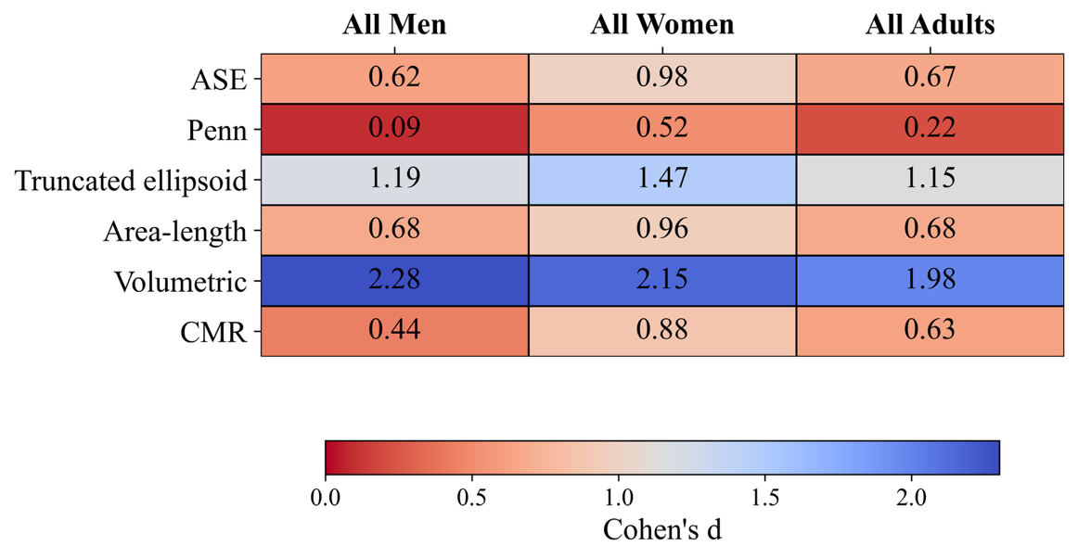
Figure 2. Comparison of CTA-derived left ventricular myocardial mass (LVMM) with published reference values obtained using linear (ASE and Penn), two-dimensional (truncated ellipsoid and area-length), and three-dimensional (volumetric) echocardiographic techniques, as well as cardiovascular magnetic resonance (CMR). Values represent the absolute Cohen’s d effect size, calculated using the sample-size-weighted pooled standard deviation. Lower values (red) indicate greater similarity to CTA-derived LVMM, whereas higher values (blue) indicate greater differences.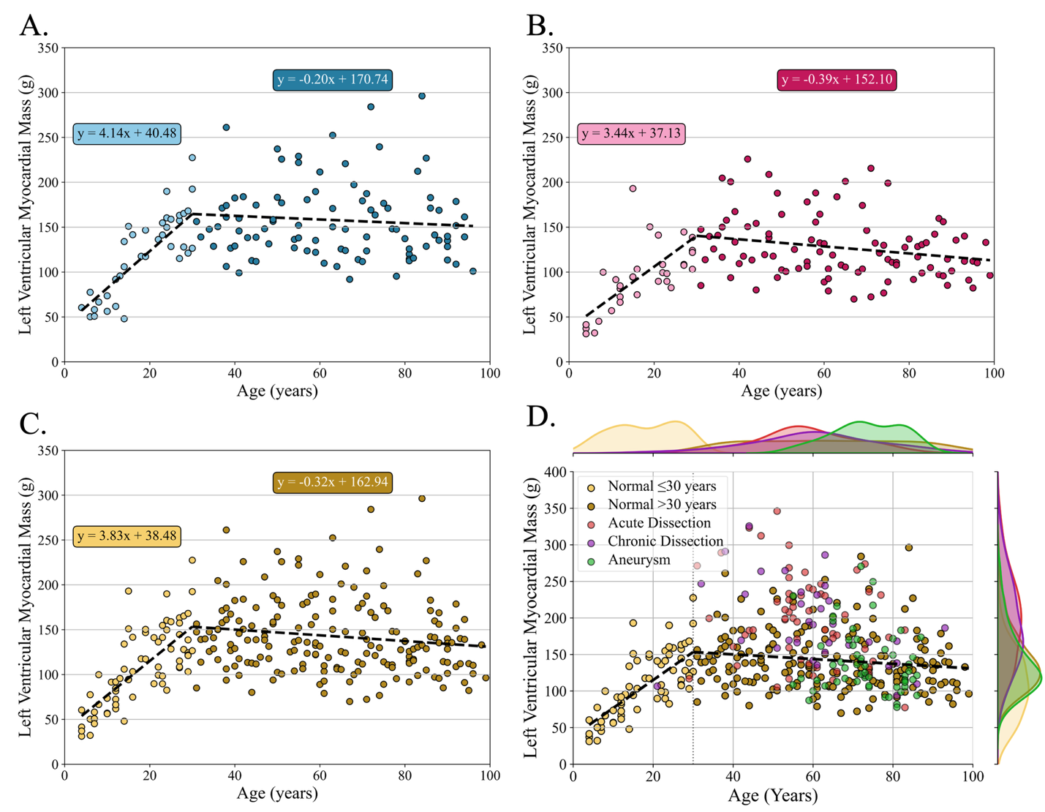
Figure 3. Left ventricular myocardial mass (LVMM) plotted by age. Normal patients are shown stratified by male sex (A), female sex (B), and overall (C); patients with acute dissection, chronic dissection, and aneurysm are shown in (D). Age 30 years was selected as the breakpoint based on the lowest sum of squared errors (SSE). Best-fit line metrics for the normal cohort were as follows: (A) ≤30 years, R² = 0.67, RMSE = 25.87 g; >30 years, R² = −0.001, RMSE = 42.40 g; (B) ≤30 years, R² = 0.43, RMSE = 27.33 g; >30 years, R² = 0.065, RMSE = 33.65 g; and (C) ≤30 years, R² = 0.56, RMSE = 28.94 g; >30 years, R² = 0.02, RMSE = 40.97 g.
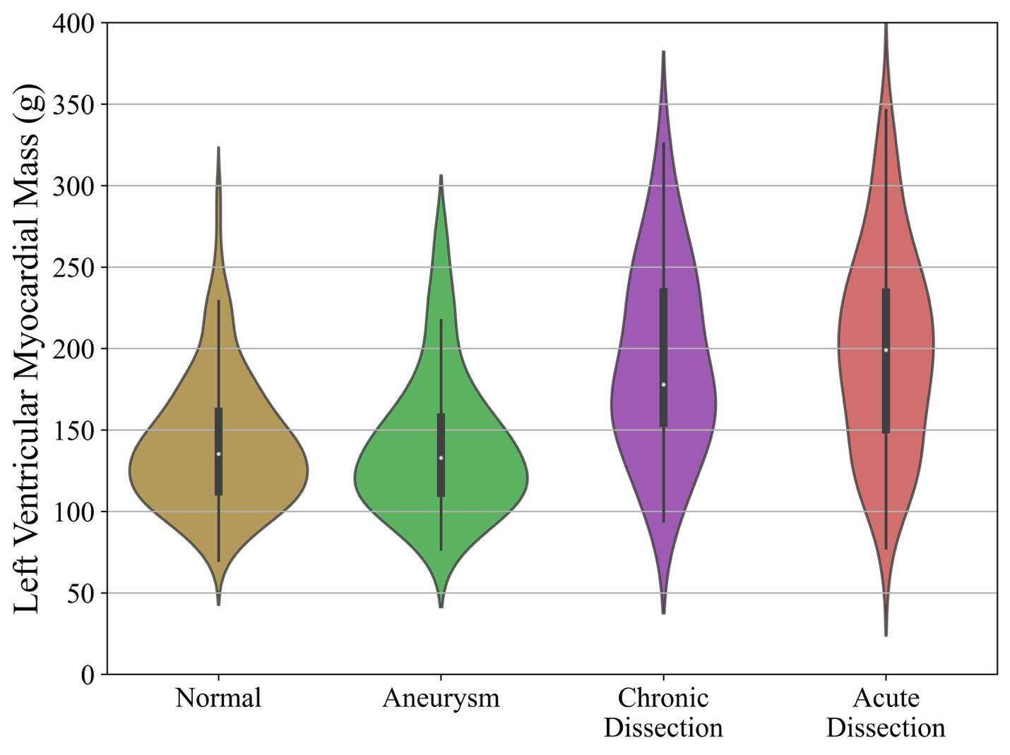
Figure 4. Violin plots illustrating the distribution of left ventricular myocardial mass (LVMM) among normal adults and patients with thoracic aortic aneurysm, chronic aortic dissection, or acute aortic dissection. LVMM was higher in the acute and chronic dissection cohorts compared with normal adults, whereas the aneurysm cohort demonstrated a similar distribution to the normal cohort. The dissection cohorts demonstrated broader distributions with visually apparent bimodality. Central markers represent mean LVMM, and the width of each violin reflects data density across the observed range.

